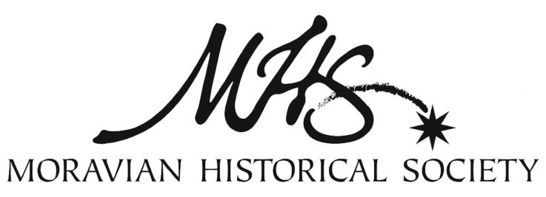

VOLUNTEER MUSEUM TOUR GUIDE PROGRAM
Do you love teaching and learning about history? Do you enjoy interacting with people of all ages?

The Moravian Historical Society invites you to serve as a volunteer museum tour guide!

As part of our team, you will:
- Provide a welcoming atmosphere and serve as an ambassador as the Museum’s first contact with the public
- Interpret the Museum’s exhibitions, helping to give the visitor a deeper understanding and appreciation of the history of the Moravians

Expand your knowledge of the Moravians’ contributions to local, regional, and international history, and share this knowledge with visitors. This is a rewarding position that requires interpretive and communication skills, a willingness to learn, and enthusiasm for the Museum, stories, and historic site of the Moravian Historical Society.

Training
Museum tour guides will attend training sessions on Museum collections, history, and stories. You will learn the skills associated with museum interpretation, including guiding and conversing with guests. These sessions are conducted by the Museum staff, including the Curator and Executive Director, as well as by guest speakers. Training will include independent reading assignments, resource materials, and short presentations. Following the training sessions, candidates must complete a satisfactory practice tour for staff and fellow volunteers.

2024 Course Schedule
All sessions meet from 10:00 to 11:30 am at the Moravian Historical Society:

- Thursday, January 25
- Thursday, February 1
- Thursday, February 8
- Thursday, February 15
- Thursday, February 22
- Thursday, March 14: Final class presentation & refreshments
- Apprentice period, March 14 – April 23, 2024: Volunteers will have 3 chances to present a successful practice tour to MHS staff and fellow volunteers by the end of this period.

Qualifications
- Excellent communication skills
- Interest in history and subjects represented in this Museum and historic site
- Ability to learn the procedures and practices of the Museum and to work with minimal supervision
- Ability to work with the public, volunteers, staff, visitors, and researchers
- Ability to operate office equipment such as computer and credit card processing

The ideal candidate will have:
- A sincere and genuine interest in connecting with people of all ages and backgrounds
- Strong verbal skills and the ability to be flexible and adaptable
- An interest in history, learning, and teaching
- Attention to detail and accuracy in relaying information to the public
- An attitude of tolerance and respect for all people’s points of view

Requirements
To remain active as a museum tour guide, each candidate must:
- Complete the training course, including the successful completion of a tour
- Become a member of the Moravian Historical Society
- Serve a minimum of two shifts each month
- Become and remain familiar with guidelines, manuals, and other resources
- Participate in continuing education programs each year
- Have a valid email address with reliable Internet access
- Successfully complete background checks

Special considerations
The Museum is located in an historic 3 ½ story building without air conditioning or an elevator.

Benefits
Tour guides receive free admission to the Museum, free or discounted admission to programs (including the Music & Lecture Series), continuing education sessions, invitation to the MHS annual volunteer appreciation event, and discounts in the Museum Store.
TOUR GUIDE APPLICATION

Please return your completed application to info@moravianhistory.org by January 22, 2024. To complete this application online, please visit www.moravianhistory.org/volunteers.

Name:___________________________________________________

Email:___________________________________________________

Phone number:__________________________________________________

Which of the following shifts would you typically be available to take? Please check all that apply:

- Monday, 1:00-4:00 pm
- Tuesday, 1:00-4:00 pm
- Wednesday, 1:00-4:00 pm
- Thursday, 1:00-4:00 pm
- Friday, 1:00-4:00 pm
- Saturday, 1:00-4:00 pm
- Sunday, 1:00-4:00 pm

The Moravian Historical Society occasionally opens outside of normal business hours (1:00-4:00 pm) to accommodate group and school tours. Please indicate whether you would typically have the flexibility to be available for the following group tour times:

- Monday mornings
- Tuesday mornings
- Wednesday mornings
- Thursday mornings
- Friday mornings
- Saturday mornings
- Sunday mornings

Why would you like to be a tour guide at the Moravian Historical Society?

What prior knowledge (if any) do you have of the Moravians?

Do you have any prior experience with public speaking?

Is there anything else you would like us to know about you?

